|  |  |  |  |
| --- | --- | --- | --- |
| **Date** | **Visiting Team** | **Home Team** | **Location** |
| 8/26/2017 | Missouri City Raiders | Pecan Grove Hurricanes | Belin Field |
|  |  |  |  |
| 9/2/2017 |  | ***BYE WEEK*** |  |
|  |  |  |  |
| 9/9/2017 | Southwest Steers | Missouri City Raiders | Thurgood Marshall High School |
|  |  |  |  |
| 9/16/2017 | Missouri City Raiders | Westside Saints | Bush High School |
|  |  |  |  |
| 9/23/2017 |  | ***BYE WEEK*** |  |
|  |  |  |  |
| 9/30/2017 | Fort Bend Titans | Missouri City Raiders | Thurgood Marshall High School |
|  |  |  |  |
| 10/7/2017 | Missouri City Raiders | Lamar Hornets | George City Park |
|  |  |  |  |
| 10/14/2017 | Southwest Redskins | Missouri City Raiders | Thurgood Marshall High School |
|  |  |  |  |
| 10/21/2017 | Missouri City Raiders | Sugar Land Cowboys | Old Kempner Stadium |

**2017 Missouri City Raiders Football schedule**

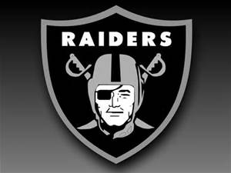

**Game Times**:

**Flag 8:00am**

**Freshmen 9:30am**

**Sophomore 11:00am**

**Junior 1:00pm**

**Senor 3:00pm**

